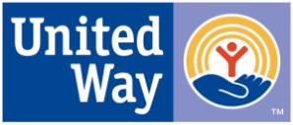
United Way of Southeast Alaska
Live United. ™
Board of Directors Meeting
Saturday January 21, 2017 6:00 pm
Gold Room, Baranof Hotel

AGENDA

- Call to Order/Roll Call – Mark Mesdag, Chair
- Approval of Agenda – Mark Mesdag, Chair
- Committee Reports- Campaign update – Sara Truitt, Resource Development Director
- Old Business-None
- New Business
a) Election of Board Members
1) Introduction and re-election of Board Members for a three year term on the Board with a term expiring January 2020
At-Large 2020
Fred Parady, Kendri Cesar
2) Introduction and election of New Board Member for a three year term on the board with a term expiring January of 2020
At-Large 2020 - Karmen Bowman
3) Introduction and election of Large Agency Representative to the Board for a two year term with a term expiring January of 2018
Large Agency Representative Millie Ryan, REACH 2018
c) Election of Officers
Board Elections: Officers

Chair- Mark Mesdag
Chair elect- Warren Russell
Secretary- Ann Gifford
Treasurer- Karmen Bowman
Past Chair- Karen Crane
IX. Adjournment – Next meeting Thursday February 16, 2017

